4.1 In 1665, Robert Hooke, the discoverer of cells, called the individual units in a tissue of cork cells because:

- They were filled with protoplasm.
- They contained a nucleus.
- They were as empty as a monk’s apartment.
- They were the basic unit of life.
- They were spherical.

4.2 Except for Henri Dutrochet, most biologists thought that plants, but not animals were composed of cells because:

- Plant cells have chloroplasts, animal cells do not.
- Plant cells have mitochondria, animal cells do not.
- Plant cells have chloroplasts and animal cells do not.
- Most animal cells have a highly visible extracellular matrix, plant cells do not.
- Most plant cells have a highly visible extracellular matrix, animal cells do not.

4.3 Mixing or convection of the cell contents of large cells is called:

- Cytoplasmic inheritance
- Photosynthesis
- Respiration
- Cytoplasmic streaming
- Cytoplasmic ribosome

4.4 Carbon dioxide and water are combined to make carbohydrate in the:

- Chloroplast
- Nucleus
- Mitochondria
- Endoplasmic Reticulum
- Golgi Apparatus

4.5 A protein that catalyzes biochemical reactions:

- is an omega fatty acid
- is an enzyme
- is an iron-rich compound
- is called a nucleic acid
- lacks nitrogen

4.6 Because the plasma membrane is differentially permeable, plant cells:

- shrink when put in a hypertonic solution.
- expand when placed in a hypotonic solution
- expand when placed in a hypertonic solution
- take up sugars faster than water
- both 1 and 2

4.7 Animal cells, but not plant cells lyse when placed into a hypotonic solution because:

- Animal cells do not have a rigid wall, plant cells do
- Animal cells do not have a chloroplast, plant cells do
- Animal cells do not have a vacuole, plant cells do
- Animal cells have nuclei, plant cells do not
- Animal cells are living.

4.8 During osmosis, water diffuses from:

- low concentration to high concentration
- high concentration to low concentration
- high light to low light
- low light to high light
- carbon to oxygen

4.9 ________form the major barrier to the movement of ATP, sugar and proteins across membranes:

- Proteins
- Carbohydrates
- Nutrients
- Lipids
- Salts

4.10 Double bond-containing fatty acyl groups of membrane lipids:

- are formed from omega fatty acids
- make the membrane more fluid at a given temperature
- are formed from unsaturated fatty acids
- may be formed from an essential fatty acid
- all of the above

4.11 Mechanochemical enzymes convert:

- chemical energy into kinetic energy
- starch into glucose
- microtubules into microfilaments
- water and carbon dioxide into carbohydrate and oxygen
- genes into chromosomes

4.12 A____________is the site of protein synthesis.

- Golgi body
- nucleus
- ribosome
- microtubule
- microfilament

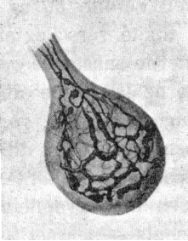

4.13 The _____________is stained with silver in the micrograph above.

- chloroplast
- mitochondrion
- Golgi apparatus
- plasma membrane
- digestive tract

4.14 Digestive enzymes are secreted through the endomembrane system in the following order:

- Golgi apparatus, endoplasmic reticulum, vacuole
- mitochondrion, microtubule, microfilament
- endoplasmic reticulum, mitochondrion, microtubule
- plasma membrane, endoplasmic reticulum, Golgi apparatus
- endoplasmic reticulum, Golgi apparatus, plasma membrane

4.15 Cells recycle components of the plasma membrane through the processes of:

- endocytosis and exocytosis
- respiration and photosynthesis
- Laurel and Hardy
- reduction and oxidation
- forming omega 3 and omega 6 fatty acids

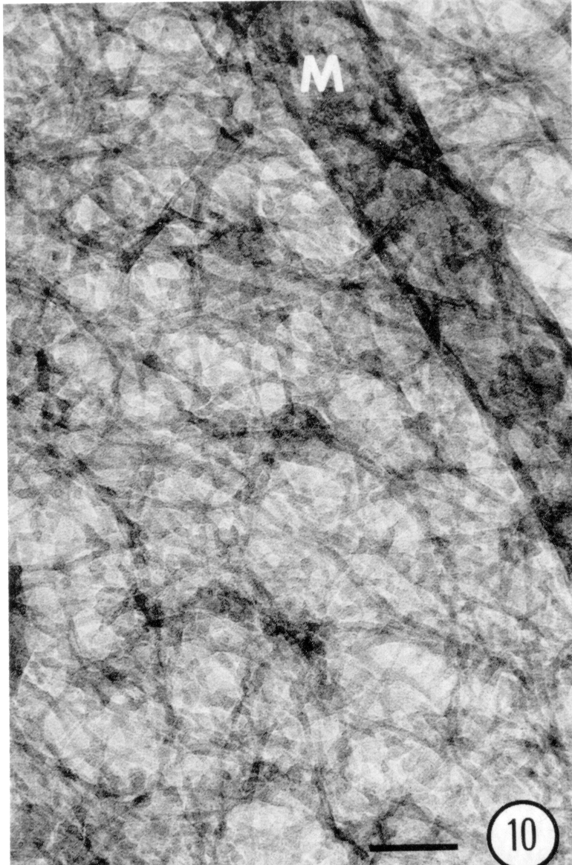

4.16 The micrograph shown above shows:

- DNA in the nucleus
- mitosis
- the microtrabecular lattice
- the stroma of the chloroplast
- the cristae of the mitochondrion

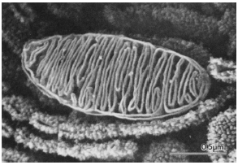

4.17 Which process takes place in the organelle depicted above?

- respiration
- DNA synthesis
- Protein synthesis
- RNA synthesis
- All of the above

4.18 According to the endosymbiotic theory

- The Golgi apparatus arose from the uptake of Golgiosomes
- Mitochondria arose from the uptake of bacteria
- Chloroplasts arose from the uptake of cyanobacteria
- All of the above
- Both 2 and 3

4.19. When one looks at a green leaf, one is seeing green light reflected from the______________.

1) Golgi apparatus.
2) ribosomes.
3) mitochondria.
4) central nucleus.
5) chloroplasts.

